1.Draw a labeled diagram of an ATX motherboard and mark at least 8 different slots and ports (such as RAM slots, PCIe slots, SATA ports, USB headers, CPU socket, power connector, etc.).
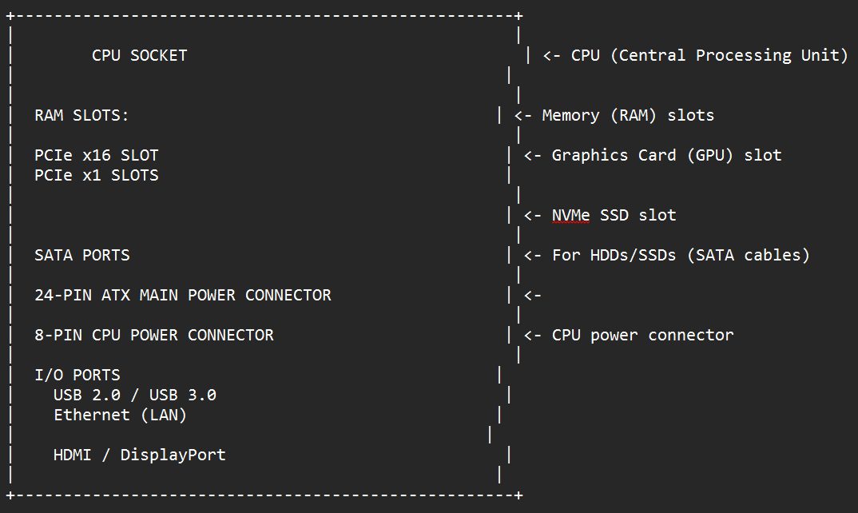

2. Research and list 3 popular CPU socket types (for example: LGA1151, AM4, LGA1200) and name one compatible CPU model for each.
Socket | Brand | Compatible CPU Example
AM4 | AMD | Ryzen 5 5600X
AM5 | AMD | Ryzen 7 7800X3D
LGA1700 | Intel | Core i7-13700K
3.Explain in your own words the primary functions of the CPU and the chipset on a motherboard, and describe how they work together when you open a music app like Spotify.
- CPU (Central Processing Unit):
  - Executes instructions from applications and the operating system.
  - Handles arithmetic, logic, and control operations.
  - Acts as the brain of the computer.
- Chipset (Motherboard Logic Controller):
  - Manages communication between CPU, RAM, storage, and peripherals.
  - Controls I/O (USB, SATA, PCIe lanes).
  - Determines feature set (overclocking, number of ports, expansion options).
Opening Spotify:
The CPU processes instructions to launch the app, decode audio streams, and manage playback.
The chipset ensures smooth data flow: fetching music files from SSD via SATA/NVMe, routing audio output through USB/audio ports, and handling background tasks like network connectivity.
Together, they create a seamless experience: CPU does the heavy lifting, chipset orchestrates the traffic.

4.Find a clear photo of a real motherboard (from the internet or your own device), and identify at least 5 different ports or slots by circling them and labeling each.